5G Ultra-Lightweight Intelligent Control Ball QC-Q1

Product Overview
The QC-Q1 series ultra-lightweight intelligent deployment ball is an integrated product designed for mobile surveillance and emergency deployment needs. Featuring a fully aluminum body, it incorporates a high-definition mechanism, 4G/5G transmission module, Bluetooth, and a high-capacity lithium battery. Capable of real-time video transmission, video recording and playback, facial recognition, license plate recognition, and noise-reduction audio pickup, it is suitable for various emergency drills and security deployment scenarios.
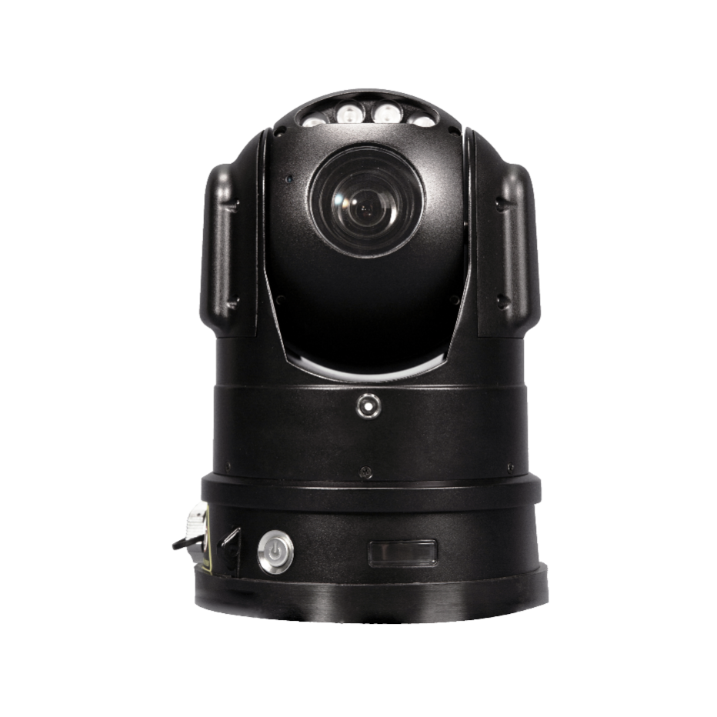

functional characteristics
Starlight night vision ensures clear night photography
Face recognition License plate recognition
Public and Private Network Integration: Adapting to Different Environments
Plug-and-play dual power interfaces
P66 Protection: Waterproof and Dustproof
Ultra-portable and lightweight design
B interface/TF card: Multiple encryption methods
3D Ball Control – One-Touch Focus
HD 1080P dual-stream transmission
Beidou/GPS dual-mode positioning

Specification Parameters
project | technical parameter
imaging sensor | 2 million CMOS sensors
minimal illumination | Black and white mode: 0.0003 lx; Color mode: 0.0007 lx
Zoom factor | Focal length: 4.6 mm to 152 mm; 20x (30x) optical zoom & 16x digital zoom
night visual range | Equipped with 4 infrared LEDs, covering a range of 100 meters, with automatic/manual activation
Cloud Platform | Horizontal 360°, Vertical-15° to 90°,255 preset positions
video coding | H.265/H.264
Video Resolution | 1080P/720P/D1/CIF
Audio Encoding | AMR/AAC/G.711
Audio Features | Built-in microphone; supports hands-free microphone and Bluetooth; customizable built-in speaker
networking protocol | Supports TCP/IP, HTTP, DHCP, DNS, RTP/RTCP, RTSP, and PPPoE
wireless network | Two SIM card slots, supports 5G networks, and is backward compatible with 4G
Wi-Fi | Supports switchable AP hotspot functionality
PDA | support
show | LCD screen displaying 5G/4G signals, positioning signals, battery capacity, and other status information
memory | Supports dual TF cards; a single card has a maximum capacity of 512 GB.
fixed position | Beidou+GPS dual-mode positioning
Conventional AI Features | Face recognition and license plate recognition are optional.
Other AI features | Customizable detection for pedestrians, motor vehicles, non-motor vehicles, and safety helmets
Interface Protocol | Supports the ONVIF protocol, GB/T 28181 protocol, and B Interface protocol.
power supply mode | Power supply: 10Ah lithium battery/DC power source
power dissipation | Normal: 7W, maximum: 20W
way to install | Magnetic mount/ tripod
levels of protection | IP66
work environment | Working temperature: -20°C to +55°C; Working humidity: 93%
Weight and Size | 2.5kg，φ156mm*217mm

application scenarios

Temporary emergency security deployment by public security authorities
This device is suitable for use at crime scenes, arrest operations, emergency situations, checkpoint security, and rapid deployment in temporary control zones. Featuring a lightweight design with dual functionality for magnetic attachment or tripod mounting, it is ready-to-use upon activation. It transmits high-definition video in real-time via 5G, supports PTZ control, AI recognition, and voice intercom functionality, meeting the needs of frontline law enforcement for rapid deployment and remote command.

Security duties for large-scale events
This system is suitable for densely populated venues such as concerts, sports events, exhibitions, gatherings, and squares. It can be flexibly deployed at critical entrances, exits, passageways, and elevated points to provide panoramic surveillance, facial recognition, license plate identification, and abnormal behavior alerts, offering visual support for on-site security, crowd management, and emergency response.

Temporary traffic control measures
Intended for traffic accident response, road construction, highway checkpoints, and temporary traffic guidance scenarios. The equipment features rapid deployment, supports license plate recognition, real-time road condition data transmission, and remote PTZ camera monitoring. When combined with voice intercom systems, it enables remote traffic guidance, thereby enhancing emergency response efficiency and standardized management protocols on roads.

Safety Production Supervision at Construction Sites/Factory Premises
Temporary supervision scenarios such as construction sites, industrial parks, and mining work areas. AI intelligently identifies behaviors including failure to wear safety helmets, unauthorized entry into restricted areas, fire hazards, and non-compliant operations, issuing real-time alerts and uploading data to the platform. This reduces on-site manual supervision demands and enables round-the-clock safety monitoring.

Power/Gas/Municipal Construction Supervision
Ideal for scenarios without power grids or electricity, such as power emergency repairs, pipeline construction, municipal operations, and field work. Featuring 5G full-network transmission, IP66-grade high protection, and long-lasting battery life, it enables 24/7 remote monitoring of construction areas, standardizes operational procedures, mitigates safety risks, and records process videos.

Water Resources / Rivers / Dams and Embankments Flood Prevention Inspection
Designed for complex outdoor environments such as riverbanks, reservoirs, dams, and flood control monitoring points. The equipment is lightweight, portable, and waterproof/dustproof, enabling rapid deployment in high-risk dam sections for night vision surveillance, water level monitoring, and intrusion detection alerts, thereby providing reliable video support for flood control duties and emergency patrols.

Temporary security for parks/property management/communities
These areas require temporary additional surveillance systems, including industrial parks, logistics parks, residential communities, campuses, and parking lots. The device features a dual installation method (magnetic adsorption/tripod), offering flexible mobility, and supports facial/license plate recognition, remote audio announcements, and video recording storage. It is suitable for theft prevention, fire safety, and access control of unauthorized personnel.

Emergency Drill and Rescue Operations
For disaster scenes such as earthquakes, floods, and landslides, as well as various emergency drill scenarios, the equipment is lightweight and portable, enabling rapid deployment in harsh environments. It provides real-time video feeds, precise positioning, and two-way communication, facilitating coordinated operations between frontline rescue teams and rear command centers.

Prison / Detention Center / Drug Rehabilitation Facility: Supplementary surveillance cameras
Key areas such as prison corridor corridors, ventilation zones, entrances/exits, and isolation zones are prioritized. The system supports high-definition night vision, AI behavior analysis, and PTZ camera patrols, seamlessly integrating with existing security platforms to cover surveillance blind spots, automatically alert for violations, and enhance regulatory safety.

Monitoring of operations in remote or out-of-area locations
Designed for wireless and power-free scenarios such as field exploration, forestry patrols, border inspections, and field construction. Featuring 5G long-distance transmission, BeiDou/GPS positioning, and long-lasting battery life, it meets the requirements for visual supervision, operational recording, and safety assurance in remote areas.

